***************** Creating local repository *******************

Mount your ISO on /dev/sr0 or on custom directory

# mount -t iso9660 -o loop /home/dan/Centos-7-x86_x64-DVD.iso /mnt/iso/

# cd /mnt/iso

Note:- Mount point will as shown in snippet

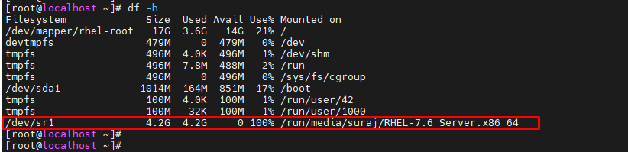

Note:- If you using virtual box use following steps

Settings→ storage→ Controller SATA→ add the disk as ISO mount

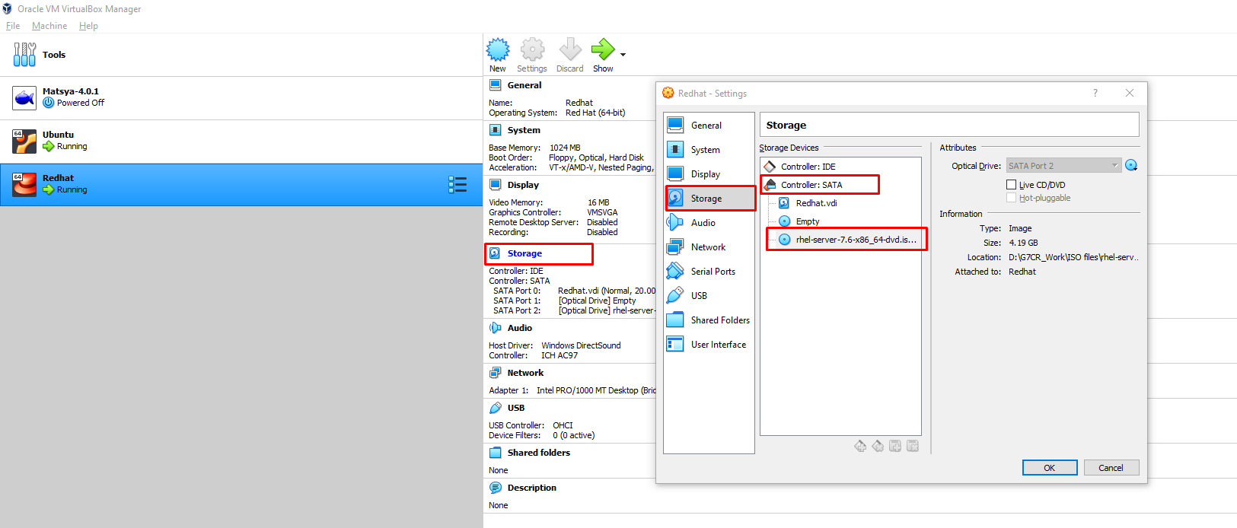

# mkdir /local-repo

# cp -R /mnt/iso/Packages/ /local-repo/

# cd /local-repo/

Install following packages for building yum repo database

# rpm -ivh Packages/deltarpm-3.6-3.el7.x86_64.rpm

# rpm -ivh Packages/python-deltarpm-3.6-3.el7.x86_64.rpm

# rpm -ivh Packages/createrepo-0.9.9-28.el7.noarch.rpm

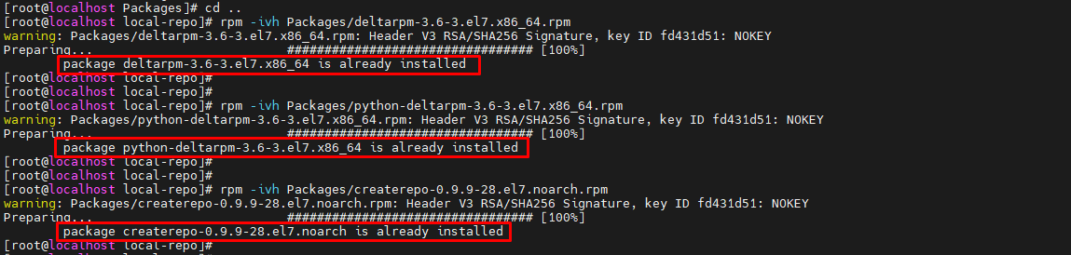

# vim /etc/yum.repos.d/local.repo

Add following lines

[LocalRepo]

name=Local-Repo

baseurl=file:///local-repo/

enabled=1

gpgcheck=0

# createrepo -v /local-repo

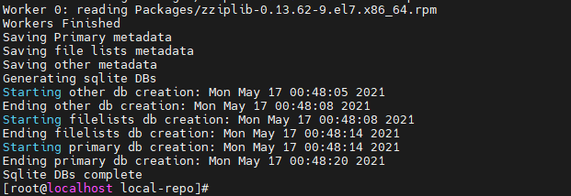

Refreshing yum database and listing the repositories

# yum clean all

# yum repolist

